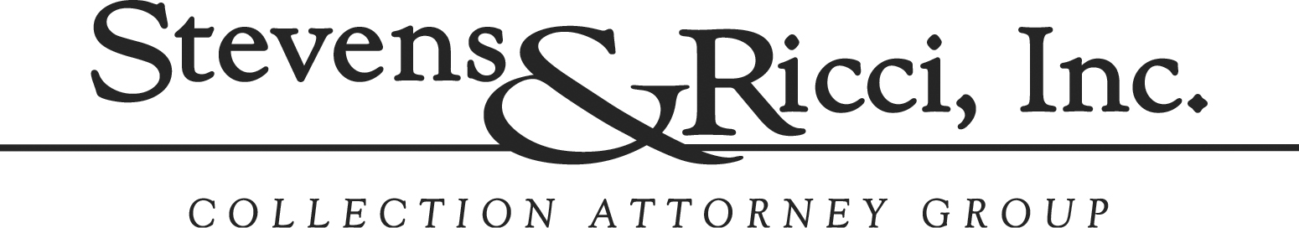

PLACEMENT FORM Date: 1/10/23

Contact: Brynn Mencarini
Contact Email: brynn@bostfiltrex.com
Company Name: Bost & Filtrex, Inc
Address: 20459 Seneca Meadows Parkway
City: Germantown
State: MD
Zip: 20876
Phone: 301.206.9466

DEBTOR: HRG Contracting

ADDRESS: 1010 Rockville Pike

CITY/STATE/ZIP: Rockville, MD 20852

PHONE/CELL/FAX: 240-685-9025

CONTACT PERSON: James Meekin or Kim Gottlieb

CUSTOMER REFERENCE #: H000748

DATE OF LAST PAYMENT: n/a

DATE OF FIRST UNPAID INVOICE: 12/31/2020

AMOUNT OWED: $14,521.79 DOCUMENTATION CHECKLIST:

INTEREST: Statement or Invoice(s) x

COLLECTION FEE: $4,487.04 Credit Appl / Pers Guar

GRAND TOTAL: $19,443.83 Copy of prior check _______

RATE

20% - U.S. accounts > $1,000 assigned up to 90 days from oldest invoice date
25% - U.S. accounts > $1,000 assigned 91 - 180 days from oldest invoice date
30% - U.S. accounts > $1,000 assigned greater than 181 days from oldest invoice
35% - Accounts less than $1,000 and accounts located outside of the U.S.

COMMENTS:

